**IAM (Identity and Access Management) –**

1. Setting Billing alarm –

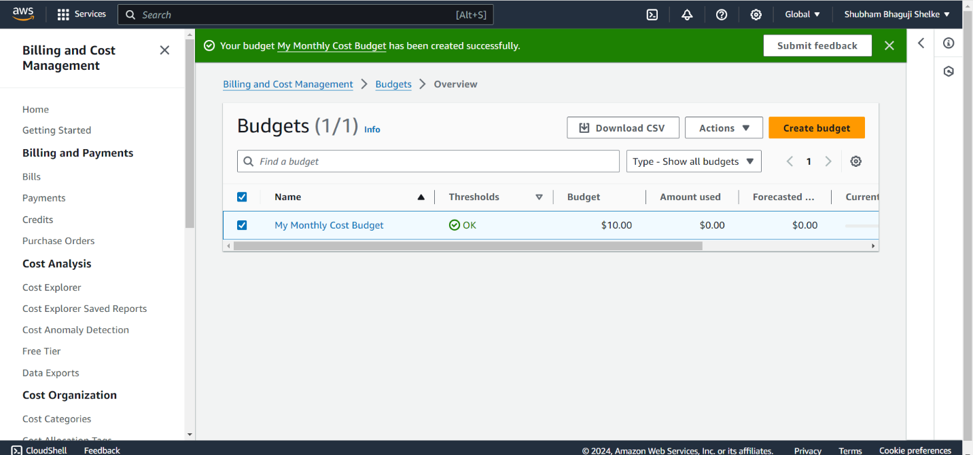

1. Create linux ec2 instance in Mumbai region –

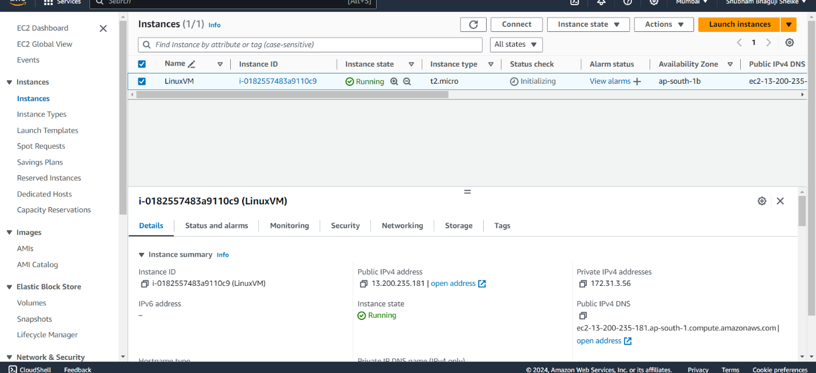

1. Create user, roles and groups using GUI

User

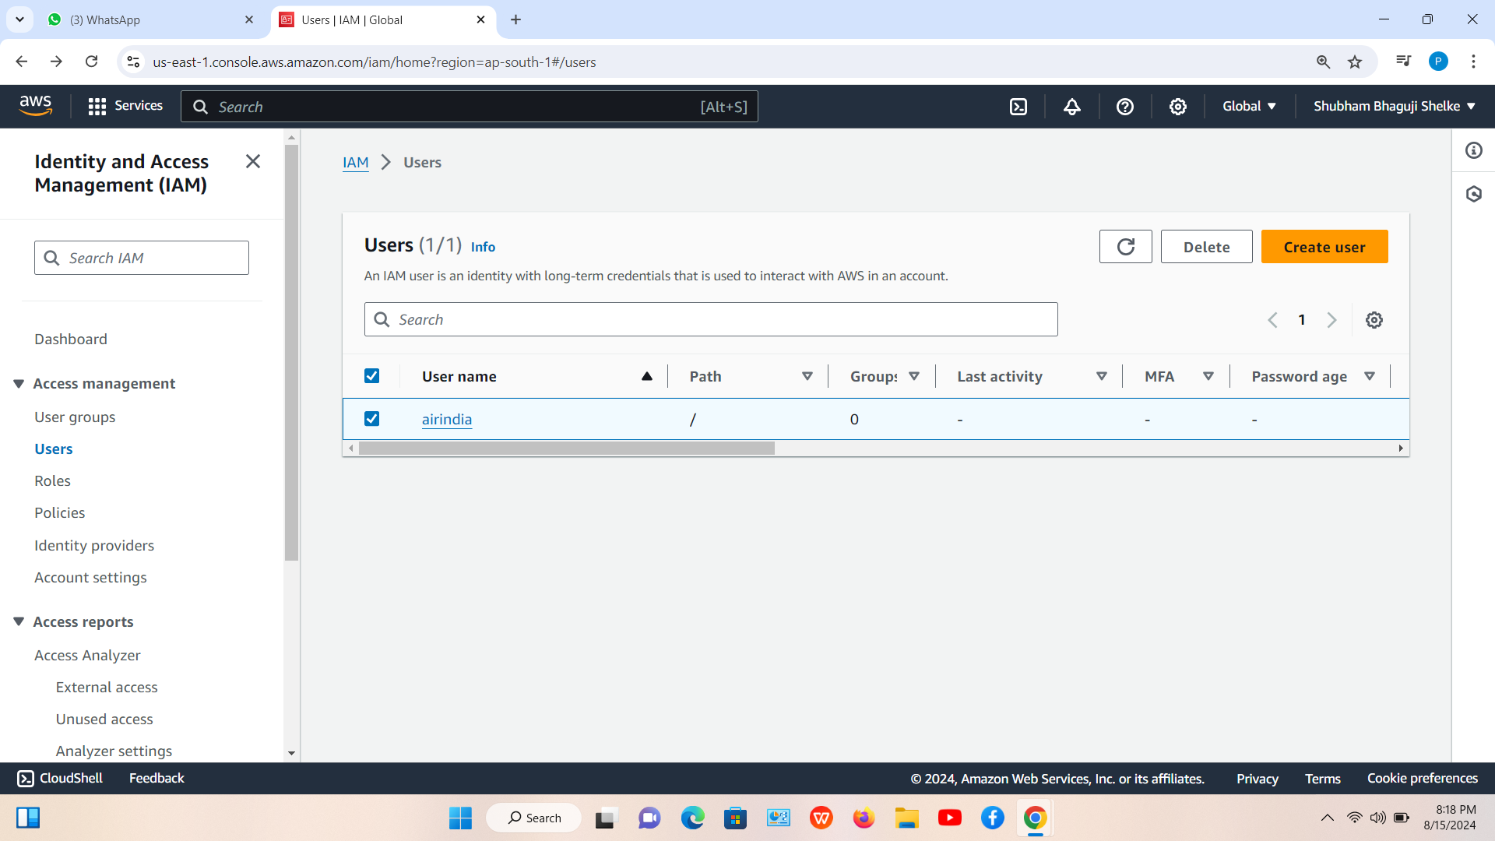

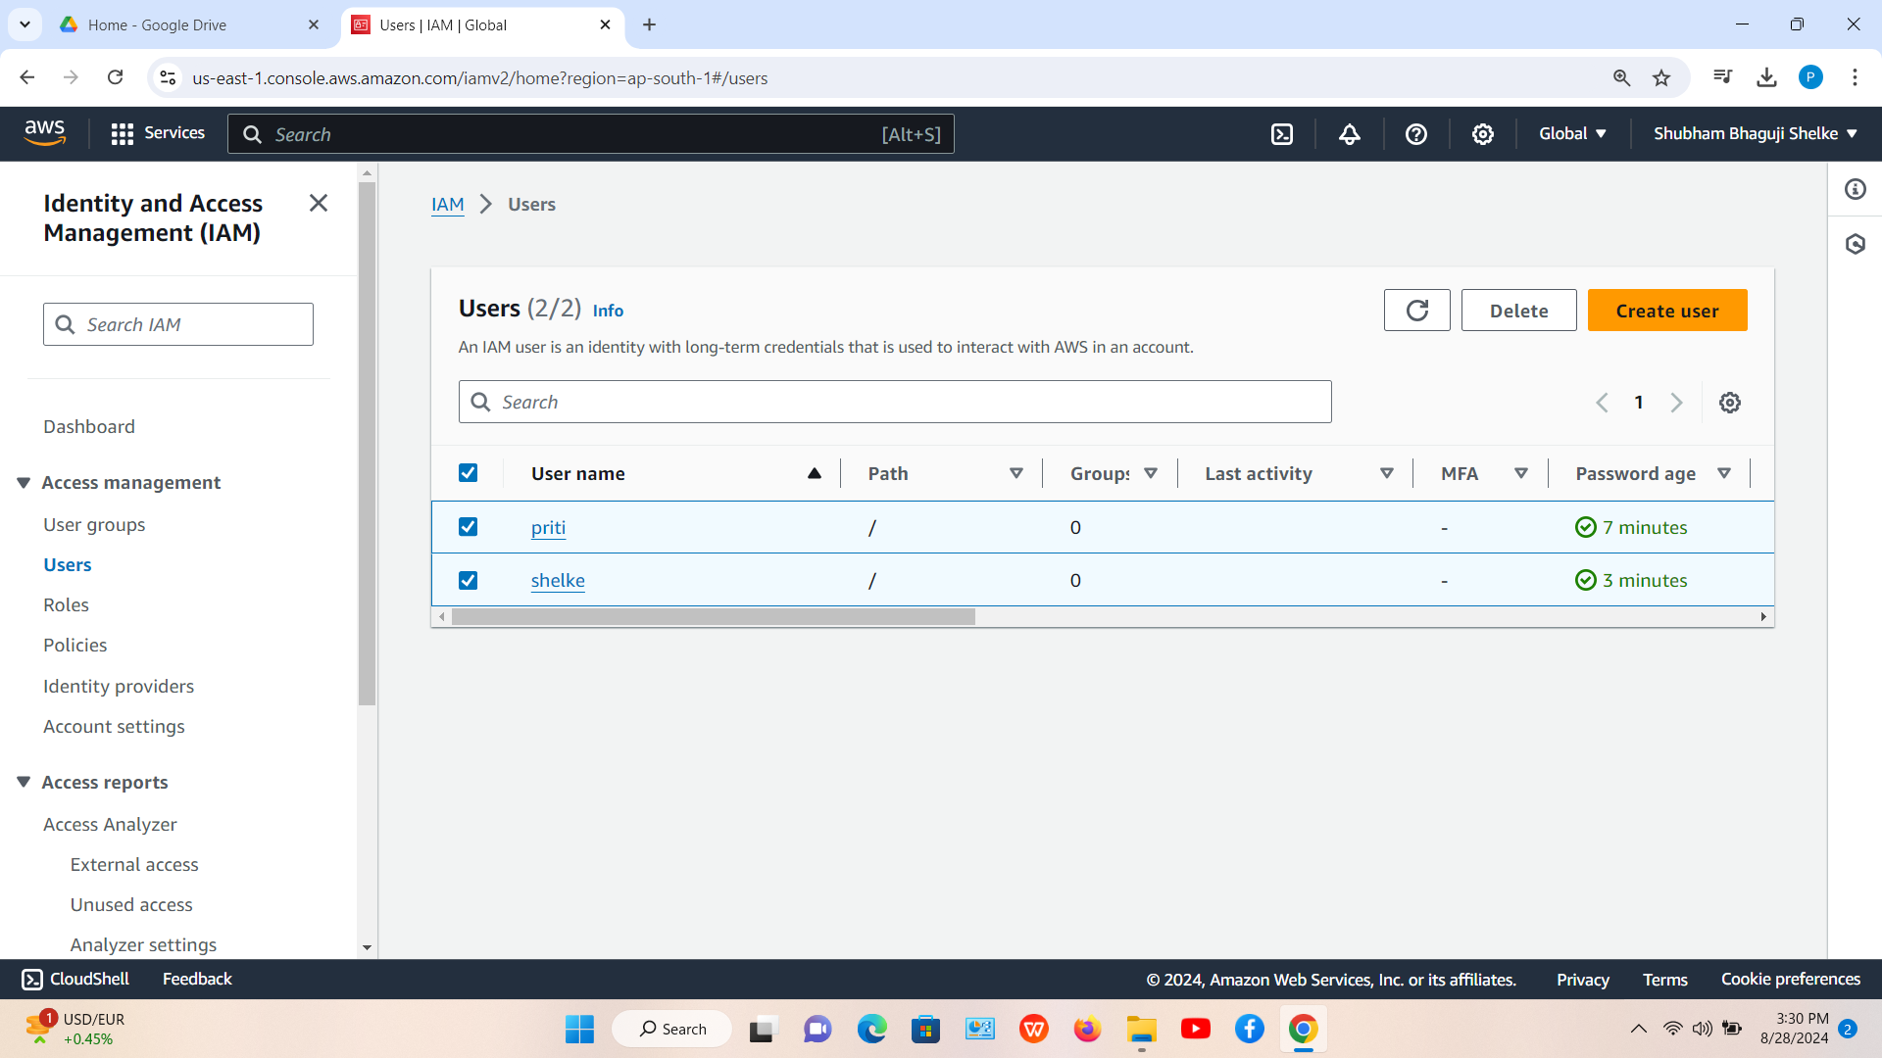

Group

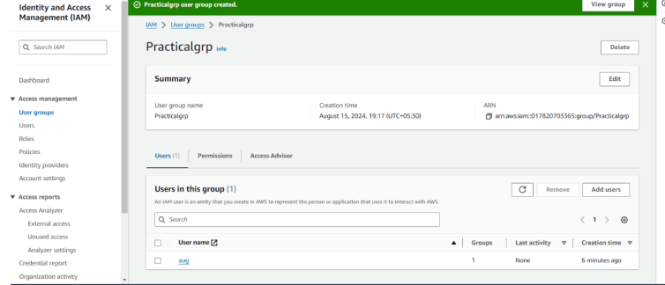

Roles

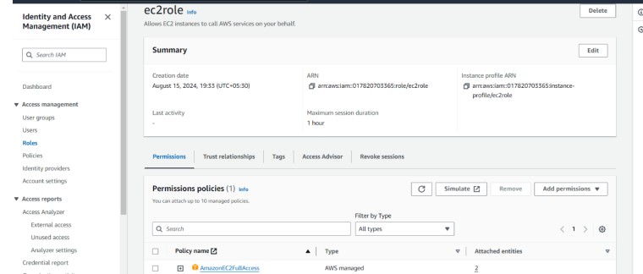

1. Create user, group and Roles using CLI

User

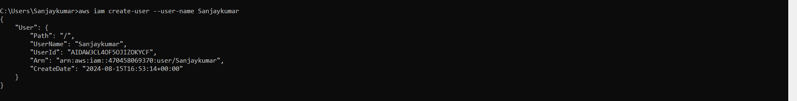

Group

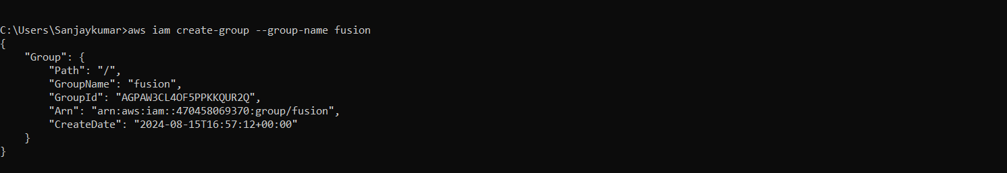

Role

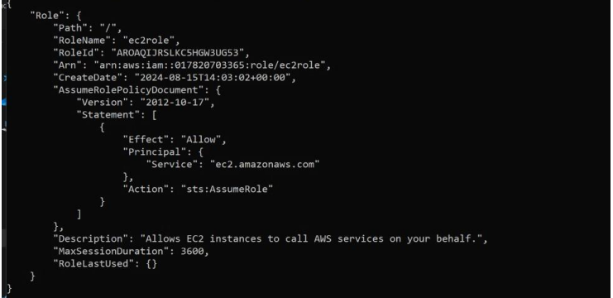

1. Attach role and access to instance

